**Getting started with Tensorflow Object detection**

#### 1) Create a new Conda virtual environment (Optional)

#### Open a new *Anaconda Prompt* window

#### The below command will create a new virtual environment with name “tensorflow_cpu”

#### Just not to mess things up, we work in new environment …;-)

(base) C:\>conda create -n tensorflow_cpu pip python=3.6

**2) Activate the virtual environment**

(base) C:\>activate tensorflow_cpu

**3) Install tensorflow**

* Below command will install tensor flow if it’s already install it will upgrade to 1.9 version

(tensorflow_cpu) C:\>pip install --ignore-installed --upgrade tensorflow==1.9

**4) Install Below basic python packages to support tensorflow**

* Install protobuf,pillow,lxml,Cython,jupyter,matplotlib,pandas and opencv-python
* Use below commands to install the required packages

(tensorflow_cpu) C:\>conda install -c anaconda protobuf

(tensorflow_cpu) C:\>pip install pillow

(tensorflow_cpu) C:\>pip install lxml

(tensorflow_cpu) C:\>pip install Cython

(tensorflow_cpu) C:\>pip install jupyter

(tensorflow_cpu) C:\>pip install matplotlib

(tensorflow_cpu) C:\>pip install pandas

(tensorflow_cpu) C:\>pip install opencv-python

**5) Setup tensorflow directory**

* **Download tensorflow models**
* Download tensorflow models from below github repository

- <https://github.com/tensorflow/models>

* Download tensorflow object detection model from below github repository

-<https://github.com/EdjeElectronics/TensorFlow-Object-Detection-API-Tutorial-Train-Multiple-Objects-Windows-10>

* **Setup directory structure** 
  + Create a folder “tensorflow” under “C” directory
  + Extract tensorflow models inside the folder “tensorflow”
  + Below is the directory structure you end up creating

C:\>tensorFlow

└─ models

├── official

├── research

├── samples

└── tutorials

* **Merge object detection model into tensorflow models**
  + Open folder “C:\TensorFlow\models\research\object_detection”
  + Extract tensorflow object detection model inside above folder

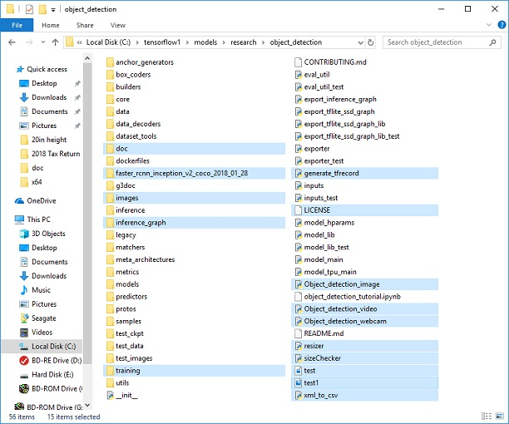

#### 6) Configure PYTHONPATH environment variable

* Excecute below command to configure PYTHONPATH

(tensorflow_cpu) C:\>set PYTHONPATH=C:\tensorFlow\models;

C:\tensorflow\models\research;C:\tensorflow\models\research\slim

#### 7) Compile Protobufs and run setup.py

* Compile the Protobuf files, which are used by tensorFlow to configure model and training parameters.
* Change directory to research folder which is under models

(tensorflow_cpu) C:\>Cd C:\TensorFlow\models\research

* Run below command to compile protobuf files

(tensorflow_cpu) C:\ TensorFlow\models\research>protoc --python_out=. .\object_detection\protos\anchor_generator.proto .\object_detection\protos\argmax_matcher.proto .\object_detection\protos\bipartite_matcher.proto .\object_detection\protos\box_coder.proto .\object_detection\protos\box_predictor.proto .\object_detection\protos\eval.proto .\object_detection\protos\faster_rcnn.proto .\object_detection\protos\faster_rcnn_box_coder.proto .\object_detection\protos\grid_anchor_generator.proto .\object_detection\protos\hyperparams.proto .\object_detection\protos\image_resizer.proto .\object_detection\protos\input_reader.proto .\object_detection\protos\losses.proto .\object_detection\protos\matcher.proto .\object_detection\protos\mean_stddev_box_coder.proto .\object_detection\protos\model.proto .\object_detection\protos\optimizer.proto .\object_detection\protos\pipeline.proto .\object_detection\protos\post_processing.proto .\object_detection\protos\preprocessor.proto .\object_detection\protos\region_similarity_calculator.proto .\object_detection\protos\square_box_coder.proto .\object_detection\protos\ssd.proto .\object_detection\protos\ssd_anchor_generator.proto .\object_detection\protos\string_int_label_map.proto .\object_detection\protos\train.proto .\object_detection\protos\keypoint_box_coder.proto .\object_detection\protos\multiscale_anchor_generator.proto .\object_detection\protos\graph_rewriter.proto

* Run below commands to build and install the models

(tensorflow_cpu) C:\ TensorFlow\models\research>python setup.py build

(tensorflow_cpu) C:\ TensorFlow\models\research>python setup.py install

#### 8) Test TensorFlow setup to verify it works

* Open object_detection_tutorial notebook using below command

(tensorflow_cpu) C:\ TensorFlow\models\research\object_detection>jupyter notebook object_detection_tutorial.ipynb

* Run the code in the notebook for object detection for pre trained model

THANKS…………………………………………………….DO MIRACLES TFOD ;-)